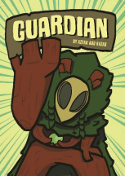

GUARDIAN

1. A cover page of my comic titled *Guardian*, inspired by the folklore creature, Bota. 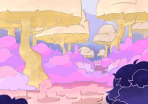

COTTON CANDY DREAMLAND (MAIN NO.1)

2. This is a background features a unique pastel colours that are visually striking.

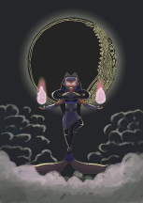

GRAHANA KALA AGNI

3. Kala Agni is a Nusantara-inspired reinterpretation of the DC Comics character, Blackfire. 

GAMEBABU

4. This illustration captures the nostalgic feeling, with pixel art heavily inspired by the Pokémon games.

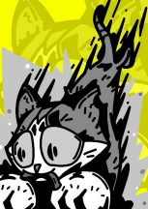

YELLOW GETAWAY

5. A dynamic illustration of the contrast between monochrome and vibrant background. 

URBAN JUNGLE

6. This is a poster for a story featuring characters inspired by classic children’s tales of Sang Kancil.

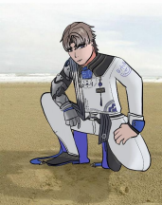

XIANGLI YAO

7. A fun little drawing featuring a character striking quirky poses to give off a playful vibe. 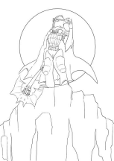

Basil the Batlord

8. An unfinished drawing of one of my favorite LEGO characters, reimagined in my own design style.

1 Favourite Quote

"Semuanya Awesome!"

Short bio (50-150 words max)

"Just a happy-go-lucky guy who loves to have fun once you get to know me. I enjoy drawing cartoon characters and have a real passion for it. Pursuing a career in animation has always been a dream of mine—there’s something special about seeing people enjoy your artwork just as much as I enjoyed watching cartoons growing up. Aside from that, I’m also a big fan of collecting collectibles, which kind of explains why my favourite animal is a raccoon. "

socmed handle or email

Instagram: @azzie.farts

Email: azzie.arts1011@gmail.com